
Sports & Entertainment

Part 1: What is Sports Marketing
Key Terms: go to Google and search and define the following terms. Then list examples of the types of items marketed under sports and under entertainment
Sports Marketing | Definitions:  Examples:
Entertainment Marketing | Definitions:  Examples:

On our class webpage is an article “What is Sports Marketing”. Read the article and answer the questions below:

- According to the article, sports marketing has gained prominence since the 1980s. It lists many activities it involves. List them here.

- According to the article, who are at least five shareholders of sports marketing (this is those involved, participating in, or impacted by sports marketing)

- What is the education level of those who work in a field related to sports marketing?

- A sports marketing graduate will understand what areas:
- Marketing specialists careers are expected to continue to grow over the next four to five year. What do they expect that jobs for marketing specialists to increase by 2020?
- What is the average wage of Marketing Mangers?
- What is the average wage of Marketing specialists?
- Three part question: Review the list of careers in sports marketing listed in the article. Using the internet, research two that you think would be fun and interesting. Describe each job, why you think this would be an interesting, and the wage.
Job Title | Answer the following
1. | Wage:  Job Description:  Why do you think interesting?
2. | Wage:  Job Description:  Why do you think interesting?

Part 2: Marketing Mix
Directions: Sports marketing, is a division of Marketing and uses the 4 Ps of marketing to market sporting and entertainment events.
Use Google and search for the term of the Marketing Mix. Define it here.

Go to Google Classroom and watch the EdPuzzle on the 4 ps of Marketing. You will answer the questions in video along with completing these notes below:
- Enter the definitions for each of the 4ps of the marketing mix below:
Product
Place
Price
Promotion

- List the items of each of 4Ps from the video:
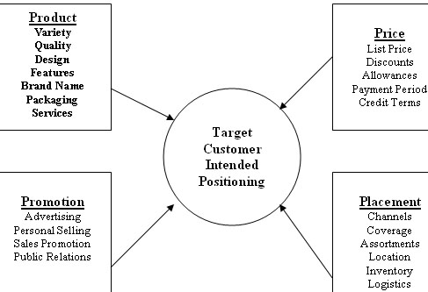
Promotion
Product
Price
Place

SECTION 1: MARKETING BASICS
What is Sports & Entertainment Marketing? | •  • a subdivision of marketing which focusses on the _____________________  of sports events, teams, or entertainment  •promotion of other products and services through these events often arise (list examples):
Primary Focus of Sports & Entertainment Marketing | •  •  •
Sports Marketing | •  • -billion dollar global industry. US Between .  • Why is it Valuable:
Entertainment Marketing | •Define entertainment marketing:  • Can be viewed , , or .  - Examples:
Marketing Mix | Review: What is the marketing mix?  •  •  •  •  When developing plans for sports and entertainment, marketers must consider the marketing mix!
Marketing Mix in Sports & Entertainment Marketing: Product | •Product  • Definition:  •Core product:  - Enhancements:  •Ancillary product:
Marketing Mix in Sports & Entertainment Marketing: Price | •Price  Definition:  •What people are willing to pay is based on:  Pricing considered for:
Marketing Mix in Sports & Entertainment Marketing: Place | •Place  • Definition:  •  •  •
Marketing Mix in Sports & Entertainment Marketing: Promotion | •Promotion  •Promotional mix:
Endorsements | Define:  •usually by a __________________ lending his/her image, name to a product  •Examples:
Sponsorships | Define:  •Examples:

SECTION 2: SPORTS MARKETING
Spending Habits of Fans | •Disposable income:  •  -Fans are willing to pay for team or celebrity identified merchandise, and for the expenses of food and travel to and from games
Sports Marketing Strategies | •Goal: attract high population of target market  •Marketing strategies used:  1)  2)  3)  4)
Sports Logos on Clothing | Why do people wear clothing that has the logos of their favorite teams or that is endorsed by a professional athlete?  •  •  •
New Sports, New Opportunities | -Opportunities for endorsements and marketing  •Example: ________________________________  •  •  •  •Elements that add excitement and build interest
Gross Impression | •  •  •Your brain records the brands it sees
Perfect Timing | •  •  •
SECTION 3: ENTERTAINMENT MARKETING
Entertainment Marketing | Define:  What is entertainment?
The Entertainment Industry | •  •$200 billion market of products and services with one goal  •Goal:  •Today, revolves around
Entertainment Marketing Then & Now | •Performing arts represent a major form of entertainment  •  •Marketing was limited to…  •Change occurred due to _____________________________  •  •
Media & Entertainment | Media:
Forms of Media Used as Entertainment Today | (Greatest amount of time to least)  1)  2)  3)  4)  5)
Vertical Distribution | Define:  Example: Walt Disney Company
Entertainment Products | 1)  2)  3)  4)  5)
Product: Film & Music | •Movies, plays, musical productions  •Concessions:  •DVD/video rentals and sales  •Record clubs:
Product: Electronics & Video Games | •  •Marketers cross-market in video game distribution:  •Advergaming:
Product: Print Books & Magazines | •  •  •Specific groups of customers buy specific magazines
Product: Theme Parks & Water Parks | •Provide recreation, but _______________________________________________  •Location-based entertainment (LBE):  •  •Edutainment:
Product: Special Entertainment Events | •  •

